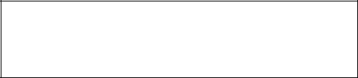

Email ID : [22.shubhagg@gmail.com](mailto:22.shubhagg@gmail.com)

Phone no: +91 - 8860874269

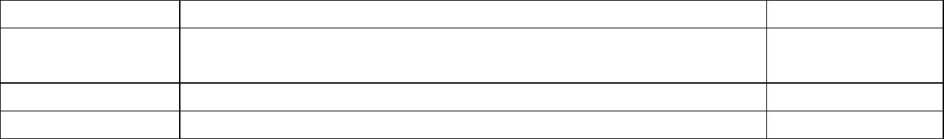SHUBHAM AGGARWAL



**Academic Qualifications:**

|  |  |  |
| --- | --- | --- |
| **Course** | **College/School** | **% / CGPA** |
| B.Tech in CSE | National Institute of Technology,Delhi | 7.14 |
| (2018-2022) |  |  |
| Class XII (2017) | Suraj Bhan DAV Public School | 80.6 |
| Class X (2015) | Suraj Bhan DAV Public School | 9.4 |



**Technical Skills:**

➔ **Languages:** C, C++, Python

➔ **IT Constructs:** DS and Algorithms, OOPS,DBMS, Operating System, Computer Netwoeks

➔ **Development tools:** Pycharm, Schi-kit learn, VS code

➔ **Frameworks:** Node.js , React.js

➔ **DB language:** SQL , Mongo DB



**Experience:**

➔ **Remote Intern**

**Dr Seema Kharb , NIT Delhi**

**06/20-07/20**

Created a model to predict the cancer survival rate using the dataset from the **National Cancer Institute** as internship



**Personnel Projects:**

➔ **Predicting the survival of Titanic passengers**: - Many decision functions were created in an attempt to predict survival outcomes from the 1912 titanic disaster using different parameters like age, sex etc using **schikit-learn** as the main library . Resulted in correctly predicting the follow-up of approximately 70% of the input data.

* **Mock Github Platform-** A platform where college students showcase their projects and see what their college peers are working on created using **MERN** stack where users can login on the platform , like and comment on the projects and search projects based on technology stacks.

➔ **E-Commerce Website:** An e-commerce application created using **MERN** stack technology. Various Functionalities such as shopping cart , login , discount and checkout system have been added for an all-round experience.



**Extra-Curricular Activities and Achievements:**

* Keen interest in Competitive programming with 5 star rating on hackerrank.
* Solved over 400 problems on Programming on platforms like SPOJ , Leetcode and geeksforgeeks.
* Executive Member, Literature Club(NIT Delhi)